FAMILY FARMING AND DAIRY POLICY REFORM

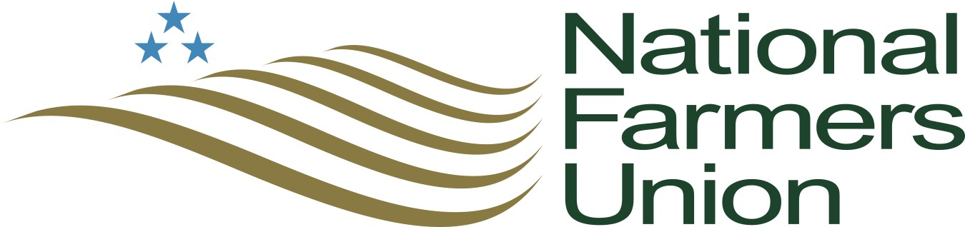 U.S dairy farms are an important segment of our nation’s economy. As one of the world’s largest dairy-producing nations, the industry provides roughly $140 billion in economic output, $29 billion in household earnings, and more than 900,000 jobs.
Despite dairy’s economic contribution to our nation, federal programs are failing producers who face difficult economic conditions. Between 2014 and 2018, roughly 7,500 U.S dairy farms went out of business as low milk prices failed to cover the average cost of production. Meanwhile, total cow numbers increased slightly and milk production remained relatively stable. The overproduction of milk and the inability for the market to stabilize following an economic downturn accelerated the loss of dairy farms throughout the U.S.
National Farmers Union recognizes efforts made by Congress to improve federal dairy programs, but the Dairy Margin Coverage program does not address the fundamental problem of oversupply. Federal dairy policy must provide both a safety net for family dairy farms in all regions and of all herd sizes, and a mechanism to manage milk supply to meet profitable demand.
A 2019 economic analysis of programs to improve dairy farm profitability showed that a system of managed growth in dairy production would have had a positive impact on the dairy economy. The results show increased milk prices, reduced price volatility, fewer dairy farm exits, and reduced government expenditures.
There is growing support among U.S dairy farmers, farm organizations, and members of congress for managing dairy production growth without issuing a strict quota, prohibiting expansion, or halting trade.
Therefore, NFU calls on Congress to establish a mandatory program for managed growth based on market demand and price stability. Such a program should increase farmer profitability by:
- Elevating milk prices
- Preventing overproduction
- Reducing milk price volatility
Such a program should also:
- Allow for beginning farmer entry
- Reduce government expenditures
- Respond to global market conditions
- Be national and mandatory so that all dairy producers participate
- Allow for on-farm processing, value-added, and direct-to-consumer sales
- Allow for planned growth in response to profitable market demand.
- Be designed in such a way that any production base does not acquire value
- Have meaningful farmer input in development, implementation, and governance

