December 10, 2019

The Honorable Donald J. Trump President

The White House

1600 Pennsylvania Avenue

Washington, DC

Dear Mr. President:

National Farmers Union (NFU) submits this letter in support of the November 25, 2019, request from the Governors’ Biofuels Coalition (the Coalition) that you direct the Administrator of the U.S. Environmental Protection Agency (EPA) to take action under Section 202 of the Clean Air Act to lower air toxic emissions caused by the use of gasoline aromatics. As explained in the Coalition’s November 25, 2019, letter, reducing the use of gasoline aromatics by enforcing Section 202 will reduce health care costs, ease compliance burdens, and provide lower fuel costs for consumers.

NFU has nearly 200,000 family farmer, rancher, and rural resident members nationwide and organized divisions in 33 states. Since 1902, we have supported family agriculture and rural communities, which are key to a safe, secure and stable food system. As part of those efforts, NFU has long-supported biofuel production as a much-needed market for farmers, particularly when rural America faces a major financial crisis in the farm sector. Domestic utilization of crops for biofuel production helps stabilize and support prices, while promoting sustainable agriculture, reducing carbon emissions, improving air quality, and enhancing the nation’s energy independence and security.

NFU has commented on the SAFE rule and other administrative proceedings supporting regulatory action to increase use of ethanol to enhance gasoline octane levels. Octane levels are a major factor driving fuel economy in engine design. Moving toward high-octane fuels to meet advances in engine design is widely supported, as they provide numerous benefits to farmers, consumers and communities across the United States. Research has shown the benefits of mid-level ethanol blends, such as E20-E40, as high-octane fuels. Mid-level ethanol blends are readily available and the most cost-effective means to reach this widely supported goal.

Section 202(l) of the Clean Air Act seeks to reduce air toxics in gasoline to the greatest degree achievable considering available technology. 42 U.S.C. §7521(l). Yet, petroleum-based aromatics, which largely replaced lead to meet gasoline octane requirements, remain a significant portion of gasoline used today, resulting in significant emissions of air toxics. They also are a key contributor to emissions of fine particulate matter, and, as noted by the Coalition, fine particulate matter emissions are likely to increase with advances in engine design if these petroleum-based aromatics continue to be used.

Ethanol, on the other hand, is substantially cleaner than petroleum-based octane additives. It reduces gasoline and vehicle emissions of particulate matter and air toxics such as benzene, toluene, and xylene. EPA has recognized that during the expansion of E10 blending between 2007 and 2012, “aromatics levels were observed to decline by a few volume percent while pump octane levels stayed constant.” 84 Fed. Reg. 26,980, 27,012 (June 10, 2019). An even greater decline in aromatics and the harmful emissions they cause would be expected to occur with a move to mid-level ethanol blends, such as E30.

NFU believes that fuel and vehicle regulation can and should work hand-in-hand to promote clean-burning, alternative renewable fuels. High octane fuels through higher blends of ethanol should be the fuel for today and the future. Virtually all parties, including EPA, acknowledge the greenhouse gas and fuel economy benefits of high-octane fuels in more efficient engines, and the cost-effectiveness of using higher ethanol blends to meet these goals. It is high time for EPA to enforce the requirements of Section 202(l) by also recognizing the benefits of higher ethanol blends to reduce air toxic emissions from gasoline and motor vehicles.

NFU thanks the Governors’ Biofuels Coalition for its efforts and stands ready to assist your Administration to meet the commitment that has been made to support rural America and biofuels, while promoting air quality and reducing overall costs for consumers.

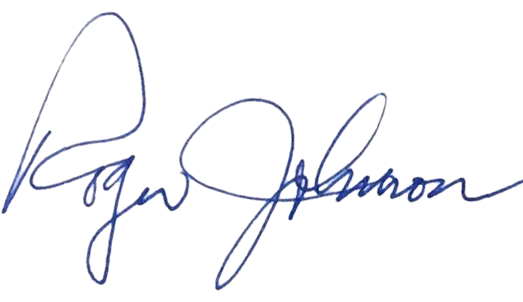

Sincerely,

Roger Johnson

President

cc: Tim Walz, Chair and Governor of Minnesota

Kristi Noem, Vice Chair and Governor of South Dakota

The Honorable Andrew Wheeler, EPA Administrator

The Honorable Sonny Perdue, Secretary of the U.S. Department of Agriculture

The Honorable Francis Brooke, Special Assistant to the President for Energy and Environmental Policy